Complete Streets Checklist

Implementation of MTC’s Complete Streets Policy, Resolution 4493, Adopted 3/25/22

Background
Since 2006, MTC’s Complete Streets (CS) Policy has promoted the development of transportation facilities that can be used by all modes. In March 2022, MTC updated its CS policy (Resolution 4493) with the goal of ensuring that people biking, walking, rolling, and taking transit are safely accommodated within the transportation network. This policy works to advance Plan Bay Area 2050 objectives of achieving mode shift, safety, equity, and vehicle miles traveled and greenhouse gas emission reductions, as well as state & local compliance with applicable CS-related laws, policies, and practices, specifically the California Complete Street Act of 2008 (Gov. Code Sections 65040.2 and 65302) and applicable local policies such as the CS resolutions adopted before January 16, 2016 (as part of MTC’s OBAG 2 requirements.)

Requirements
MTC’s CS Policy requires that all projects (with a total project cost of $250,000 or more) applying for regional discretionary transportation funding – or requesting regional endorsement or approval through MTC – must submit a Complete Streets Checklist (Checklist) to MTC.
Please note that projects claiming exceptions to the CS Policy must complete the Exceptions section on the Checklist, including the BPAC review, and provide a Department Director-level signature. Please fill out Contact Information and Project Information and then move to Statement of Exception, which is the last section.

Additional information and guidance for completing this Checklist can be found at the MTC Administrative Guidance: Complete Streets Policy Guidance for public agency staff implementing MTC Resolution 4493 at https://mtc.ca.gov/planning/transportation/complete-streets
This form may be downloaded at https://mtc.ca.gov/planning/transportation/complete-streets.

Submittal
Completed Checklists should be submitted online via this form.

PROJECT INFORMATION

Project Name/Title:

Project Area/Location(s):

Attach map if available.

PROJECT DESCRIPTION: (300-word limit)
Please indicate project phase (Planning, PE, ENV, ROW, CON, O&M)

May attach additional project documents, cross sections, plan view, or other supporting materials.

CONTACT INFORMATION

Contact Name & Title: | Contact Email: | Contact Phone:
Agency:

Do you think your project qualifies for a Statement of Exception? (see qualifying list in pg. 4)
  - Yes
  - No

Topic | CS Policy Consideration | YES | NO | Required Description
- Bicycle, Pedestrian and Transit Planning | Does Project implement relevant Plans, or other locally adopted recommendations?  Plan examples include:  - City/County General + Area Plans  - Bicycle, Pedestrian & Transit Plan  - Community-Based Transportation Plan  - ADA Transition Plan  - Station Access Plan  - Short-Range Transit Plan  - Vision Zero/Systematic Safety Plan |  |  | Please provide detail on Plan recommendations affecting Project area, if any, with Plan adoption date.  If Project is inconsistent with adopted Plans, please provide explanation.
- Active Transportation Network | Does the project area contain segments of the regional Active Transportation (AT) Network?  [See AT Network map on the MTC Complete Streets webpage.] |  |  | If yes, describe how project adheres to the NACTO “Designing for All Ages and Abilities Contextual Guidance for High-Comfort Bicycle Facilities” and/or the Architectural and Transportation Barriers Compliance Board’s “Accessibility Guidelines for Pedestrian Facilities in the Public Right of Way.” See Attachment 1.
- Safety and Comfort | - Is the Project on a known High Injury Network (HIN) or has a local traffic safety analysis found a high incidence of bicyclist/ pedestrian-involved crashes within the project area? |  |  | Please summarize the traffic safety conditions and describe Project’s traffic safety measures. The Bay Area Vision Zero System may be a resource.
 | - Does the project seek to improve bicyclist and/or pedestrian conditions? If the project includes a bikeway, was a Level of Traffic Stress (LTS), or similar user experience analyses conducted? |  |  | Describe how project seeks to provide low-stress transportation facilities or reduce a facility’s LTS.
- Transit Coordination | - Are there existing public transit facilities (stop or station) in the project area? |  |  | List transit facilities (stop, station, or route) and all affected agencies.
 | - Have all potentially affected transit agencies had the opportunity to review this project? |  |  | Please provide confirmation email from transit operator(s).
 | - Is there a MTC Mobility Hub within the project area? |  |  | If yes, please describe outreach to mobility providers, and Project’s Hub-supportive elements, found in MTC’s Mobility Hub Implementation Playbook
- Design | Does the project meet professional design standards or guidelines appropriate for bicycle and/or pedestrian facilities? |  |  | Please provide Class designation for bikeways. Cite design standards used.
- Equity | Will Project improve active transportation in an Equity Priority Community (EPC)? |  |  | Please list EPC(s) affected.
- BPAC Review | Has a local (city or county) Bicycle and Pedestrian Advisory Commission (BPAC) reviewed this checklist. The CS Checklist MTC review will begin once the BPAC meeting has occurred. |  |  | Please provide meeting date(s) and a summary of comments, if any.

Statement of Compliance | YES
The proposed Project complies with California Complete Street Act of 2008 (Gov. Code Sections 65040.2 and 65302, MTC Complete Streets Policy (Reso. 4493), and locally adopted Complete Streets resolutions (adopted as OBAG 2 (Reso. 4202) requirement, Resolution 4202).

If no, complete Statement of Exception and obtain necessary signature.

Statement of Exception | YES |  | Provide Documentation  or Explanation
- The affected roadway is legally prohibited for use by bicyclists and/or pedestrians. |  |  | If yes, please cite language and agency citing prohibited use.
- The costs of providing Complete Streets improvements are excessively disproportionate to the need or probable use (defined as more than 20 percent for Complete Streets elements of the total project cost). |  |  | If claimed, the agency must include proportionate alternatives and still provide safe accommodation of people biking, walking, and rolling.
- There is a documented Alternative Plan to implement Complete Streets and/or on a nearby parallel route. |  |  | Describe Alternative Plan/Project
- Conditions exist in which policy requirements may not be able to be met, such as fire and safety specifications, spatial conflicts on the roadway with transit or environmental concerns, defined as abutting conservation land or severe topological constraints. |  |  | Describe condition(s) that prohibit implementation of CS policy requirements

SIGNATURES / NOTIFICATIONS

TRANSIT
The project sponsor shall communicate and coordinate with all transit agencies with operations affected by the proposed project. If a project includes a transit stop/station, or is located along a transit route, the Checklist must include written documentation (e.g. email) with the affected transit agency(ies) to confirm transit agency coordination and acknowledgement of the project. A CS Checklist Transit Agency Contact List is available for reference.

DEPARTMENT DIRECTOR-LEVEL SIGNATURE FOR EXCEPTIONS
Exceptions must be signed by a Department Director-level agency representative, or their designee, and not the Project Manager. Insert electronic signature or sign below:

Full Name:
Title:
Date:
Signature:

ATTACHMENT 1 – All Ages and Abilities and Guidelines

- All Ages and Abilities
Designing for All Ages & Abilities, Contextual Guidance for High-Comfort Bicycle Facilities, National Association of Transportation Officials, December 2017

Projects on the AT Network shall incorporate design principles based on designing for “All Ages and Abilities,” contextual guidance provided by the National Association of City Transportation Officials (NACTO), and consistent with state and national best practices. A facility that serves “all ages and abilities” is one that effectively serves the mobility needs of children, older adults, and people with disabilities and in doing so, works for everyone else. The all ages and abilities approach also strives to serve all users, regardless of age, ability, ethnicity, race, sex, income, or disability, by embodying national and international best practices related to traffic calming, speed reduction, and roadway design to increase user safety and comfort. This approach also includes the use of traffic calming elements or facilities separated from motor vehicle traffic, both of which can offer a greater feeling of safety and appeal to a wider spectrum of the public.
Design best practices for safe street crossings, pedestrian facilities, and Americans with Disabilities Act (ADA) accessibility at transit stops, and bicycle/micromobility facilities on the AT Network should be incorporated throughout the entirety of the project. The Proposed Public Rights-of-Way Accessibility Guidelines (PROWAG) by the U.S. Access Board should also be referenced during design. (See table on next page for guidelines)
- Design Guidance
Examples of applicable design guidance documents include (but are not limited to):
American Association of State Highway and Transportation Officials (AASHTO) – A Policy on Geometric Design of Highway and Streets, Guide for the Development of Bicycle Facilities, Guide for the Planning, Design, and Operation of Pedestrian Facilities; Public Right-of-Way Accessibility Guide (PROWAG); Manual on Uniform Traffic Control Devices (MUTCD); Americans with Disabilities Act Accessibility Guidelines (ADAAG); National Association of City Transportation Officials (NACTO) – Urban Bikeway Design Guide.

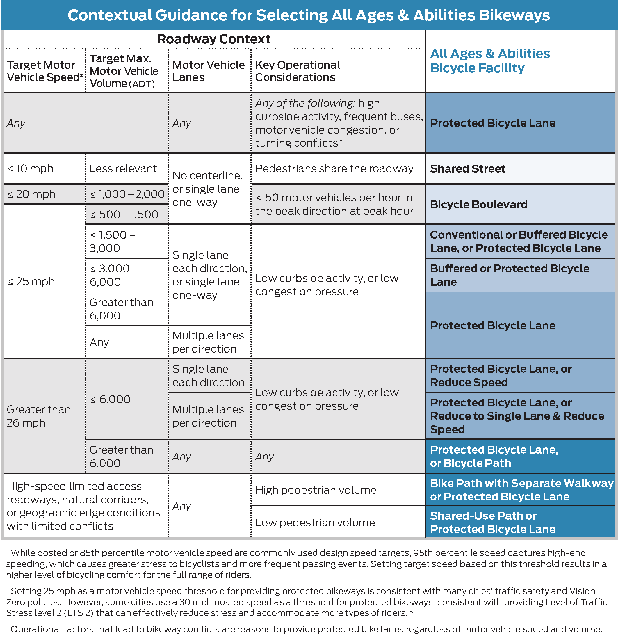
Figure 1 Designing for All Ages & Abilities, NACTO https://nacto.org/wp-content/uploads/2017/12/NACTO_Designing-for-All-Ages-Abilities.pdf

